Assignment-1

1. You have just moved to Washington, D.C., to work for the U.S. House of Representatives (the “House”) as a database specialist. For your first job, they want you to design a database to keep track of votes taken in the House. (A counterpart to you working for the U.S. Senate is designing a similar database for tracking votes in the Senate)

The database will track votes taken in the House during the current two-year congressional session. It should record each U.S. state (for instance, Texas) with its name, number of representatives, and region in which the state is located (northeast, mid-atlantic, midwest, and so forth). Each congress-creature, er, I mean representative, in the House is to be described by his or her name, the district (by district number) that he or she represents, the year when he or she was first elected, and the political party to which he or she belongs (for instance, Republican, Democrat, Independent, Green, Reform, Other). The database should track each bill (legislation) with its name, the date on which its vote was taken, whether the bill passed or failed (so the domain is yes and no), and its sponsors (the representatives who proposed the bill). The database should track how each representative voted on each bill (yes, no, abstain, absent).

**Design an entity-relationship (E-R) schema diagram for the above enterprise. State clearly any assumptions that you make.**

1. In this example problem, you will create a database for an organization with many departments. Each department has employees and employees have dependents. To create a database for the company, read the description and identify all the entities from the description of the company. The company organized into departments and departments have employees working in it. Attributes of Department are dno, dname. Attributes of Employee include eno, name, dob,gender, doj, designation, basic_pay, panno, skills. Skills are multi-valued attribute. The Department has a manager managing it. There are also supervisors in Department who supervises a set of employees. Each Department enrolls a number of projects. Attributes of Project are pcode, pname. A project is enrolled by a department. An employee can work on any number of projects on a given day. The Date of employee work in-time and out-time has to keep track. The Company also maintains details of the dependents of each employee. Attributes of dependent include dname, dob, gender and relationship with the employee.

**Draw an entity-relationship diagram and identify the relational table from the ER Diagram for the above scenario.**

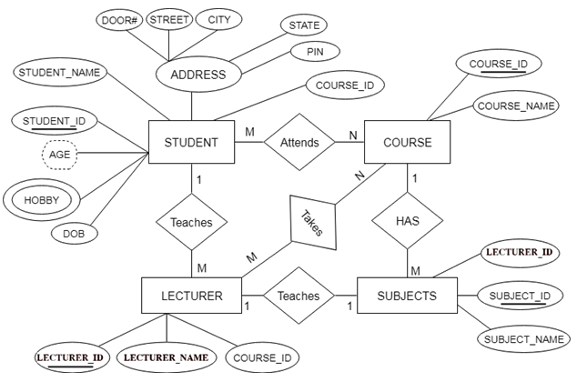

**Using the above ER diagram, draw a relational tables from it.**